Lockheed Martin EIS Windchill Training Plan

Created for
Lockheed Martin EIS
Orlando, Florida USA
Prepared by: PTC Global Services Group
March 27, 2000
This proposal has been prepared specifically for Lockheed Martin EIS. It remains the property of PTC and its contents may not be disclosed to any third party without PTC's prior consent.

Executive Summary
The purpose of this proposal is to provide LOCKHEED MARTIN EIS information regarding the Windchill training options available within PTC Education Services.
This proposal has been written under the supposition that the training options outlined within are to be executed during a Windchill / MITIC “Phase I” production implementation at a the LOCKHEED MARTIN EIS facility. Though there are three phases to the Windchill / MITIC production implementation, this proposal will address Phase II training needs in the form of a “Budgetary Estimate”. Phase III training needs will not be addressed. This methodology is being applied to support an iterative process which allows “best-in-case” training solutions to be utilized at the appropriate time based on “lessons learned” during early training engagements.
The training options presented in this evaluation will allow LOCKHEED MARTIN EIS to determine the training methodology best suited to train their Windchill / MITIC installers, developers and end-users.
The training options presented will range from delivery of standard PTC Education Services Windchill training courses to development and delivery of fully customized training courses. The Windchill training options presented will allow LOCKHEED MARTIN EIS budgets to be focused on core deficiencies, reducing the total cost of ownership of implementing Windchill.

Activities outlined in this evaluation will define the requirements, methodologies and pricing necessary to assist LOCKHEED MARTIN EIS in selecting the training course delivery scheme best suited for LOCKHEED MARTIN EIS Windchill / MITIC users.
Standard and Custom training options focuses on several key themes
- Profiling and stratifying the user base into discrete job tasks
- Skill Development Plan customized for each user addressing these tasks
- Custom development of training classes to focus on LOCKHEED MARTIN EIS’s methods, processes, and best practices
- On-site or in-center delivery of instructor-led classes.
- Integration of training and evaluation with pilot projects
- Integration of consulting during pilot projects

However, users will gain added value from Custom l training options because:
- Custom training condenses the learning curve, allowing assimilation of more material in less time

This proposal also addresses the options for establishing a partnership between PTC Education Services and Lockheed Martin EIS for the reselling of Windchill training to Lockheed Martin EIS customers, suppliers and vendors.

Costs:
The cost of implementing the PTC LM EIS Windchill / MITIC training plan is:
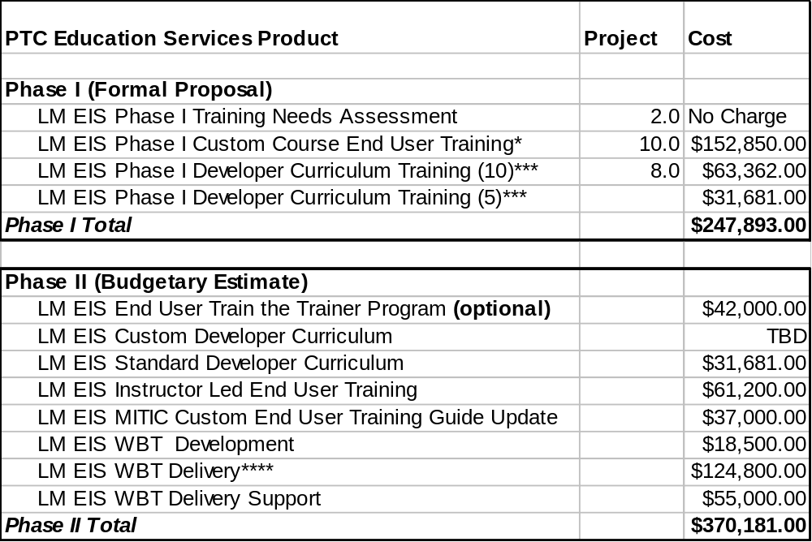
* cost includes course development and “on-site” delivery
**cost is a MINIMUM value; further discussions regarding custom developer curriculum, delivery of WBT’s and the LM EIS resale of WBT’s could significantly increase this value.
Also, Train the Trainer cost not included in Phase II sub-total.
***Cost is for a total of 15 developers. Assumption: second set (5) one half price of original set (10).
**** “Early Adopter Price”, Cost is minimum based on 240 users.

Recommendations

Prerequisites
Certain prerequisite skills are desirable to establish the foundation in which a Windchill curriculum will build. Formal education, experience base, technical skills, and communication skills comprise a prerequisite skill set that should be considered when identifying individual candidates for Windchill development training. Because PTC has been highly successful at building a competent Windchill workforce by selecting candidates that engage in the prerequisites listed in Projects 6.0 and 7.0 , PTC recommends Lockheed Martin to have their Windchill development training candidates participate in these prerequisites as well. For the timely success of the Windchill / MITIC Phase I production implementation, these prerequisites should be completed by May 31,2000.

Lockheed Martin EIS Training Insights

PTC Education Services recommends the Lockheed Martin Windchill / MITIC development personnel to attend its standard Windchill training courses prior to Windchill production installation by PTC GSO Windchill implementation specialist. The standard courses to be attended are listed in Project 8.0 of this proposal.This will equip the Lockheed Martin EIS Windchill development staff with the ability to collaborate with the PTC GSO Windchill implementation specialist during Windchill implementation.
PTC education services also recommends the Lockheed Martin EIS Windchill / MITIC technicial managers also attend the following PTC standard Windchill courses:
- Install the Windchill System Components
- Administer the Windchill Business Environment
- Objetct Oriented Analysis and Design
These courses will provide the technical managers with insight on the obstacles faced by the members of their development staff.

End - User Training Recommendations

End - User Training Phase I
PTC Education Services recommends Lockheed Martin EIS to have its Phase I end users attend an instructor led custom training course. We perceive this teaching medium as being the most productive method for addressing the low number of end users during this phase. We recommend all identified user “roles” be represented in this course.

End - User Training Phase II (Budgetary Estimate)
PTC Education Services recommends Lockheed Martin EIS to have its Phase II end users educated through an internal Train the Trainer program during the first half of Phase II. We recommend that the internal trainer led courses be more “role-specific” structured for increased learning efficiency.
For the second half of Phase II, we recommend Lockheed Martin EIS to consider using the PTC Education Services Web Based Tutorial (WBT) format for training its Windchill / MITIC end-users to optimize learning efficiency.

End – User Training Phase III (No Estimate)
PTC Education Services recommends Lockheed Martin EIS to re-evaluate which of the three end user training formats proved to be the most cost-efficient and productive for the user roles identified per this proposal. Based on the evaluation results, Lockheed Martin EIS should then apply the appropriate training methodology to the applicable role.

Additional User Training Methodology

Internal Mentoring Program
PTC Education Services recommends LM EIS MITIC program management to establish an internal mentoring program to expedite end-user proficiency levels. We suggest that some of the Windchill / MITIC developers be designated as “Super Users” and some of their daily tasks involve addressing new user issues, as well as the establishment and documentation of LM EIS Windchill / MITIC best practices.
Benefits of this program will be high user morale and low productivity impact due to user attrition because of documented shared information.

Management Overview Training
PTC Education Services recommends LM EIS MITIC program management to consider constructing a “Windchill / MITIC Management Overview” course for affected LM EIS executive staff. This course should inform the LM EIS executive staff about the purpose, principles and processes involved with the Windchill / MITIC program.
The benefits of this program will be the encouragement of LM EIS executive staff to employ MITIC throughout their respective organizations.

Support Acknowledgements
PTC would like to thank the following individuals from whom information presented in this Windchill Training Plan is based:

Paul Gage Business Process Manager
Bob Davidson Business Process Manager
Rock Whitney Development Engineer
George Walther Consulting Engineer

Windchill / MITIC Phase I - Training Plan Projects
Project 1.0  Lockheed Martin EIS Training Objectives | The Training Objectives for this Windchill Training Plan are as follows.  - Develop a fully trained Windchill development team of IT professionals within Lockheed Martin EIS. This team will be capable of trouble shooting and modifying existing Windchill applications delivered by PTC, or designing, developing and implementing new Windchill Solutions as required. This includes both code development and administrative support capabilities for the Windchill product. The development team must be fully trained and qualified to assume Windchill development roles prior to October 2000.  Development Team Members:  - Solution Architect: Develop Windchill Solution Architects capable of leading the design, development, and implementation of Windchill solutions. The solution architects must be fully trained and qualified to assume Windchill solution architect roles prior to October 2000.  - Windchill Developer: Develop Windchill application Developers that are capable of designing, developing, and implementing Windchill solutions as required. These personnel would work under the direction of the Solution Architect to implement and support the MITIC application. The Developers must be fully trained and qualified to assume Windchill development roles prior to October 2000.  - Info*Engine Solution Architect: Develop Info*Engine Solution Architects / developers capable of designing, developing, and implementing Windchill Info*Engine based solutions by October 2000.  Support Team Members:  - System Administrator: Develop a group of system administrators to provide support services and daily administrative support to the users of the MITIC system implementation. These team members will provide the help desk support and day to day operations support of the system including backups, LAN system performance monitoring, system technical support and other system level issues.  - MITIC Administrator: Develop a group of support personnel to provide the day-to-day user support. These personnel will be able to provide answers for users questions, for help desk issues, and system application questions. These personnel will be able to provide user assistance for, and problem resolution of, LM Project and proposal issues and the application of the MITIC tool to project specific, user questions.  - MITIC Trainer: Develop and certify a group of LM personnel that Understand how to setup and deliver an effective End User training program after production deployment requirements are known. (late Phase II)
Project 2.0  PTC Methodology and Approach | Methodology - Given the comprehensive nature and extensive collaboration capabilities of the Lockheed Martin EIS Windchill implementation, end user training, internal support training, and development team training will require a carefully designed combination of standard and custom developed course curricula as well as in-house end-user and internal support training.  Approach:  - Identify the different categories of audiences in order to offer learning solutions targeted to each category.  - Perform an assessment to develop a baseline of current Lockheed Martin EIS skill sets and perform a gap analysis to identify the requirements for the complete education of the Lockheed Martin EIS team.  - Identify any third party courses or learning materials needed to ensure that the Lockheed Martin EIS team is capable and prepared to successfully implement Windchill.  - Base training content on role requirements, not product features and functions.  - Identify a custom-tailored Lockheed Martin EIS Windchill Curriculum Plan, including recommendations for:  - Windchill Technical Courses.  - Prerequisite courses to ensure success with the Windchill course work.  - Computer Based Training recommendations to fill the gaps in commercial courses.  - Use best-in-class methods of delivery to allow flexibility in implementation and reduction of training costs while delivering the highest quality solution.  - Develop a Lockheed Martin EIS Windchill Curriculum Plan for the core implementation team. We recommend measuring this plan against the overall program objectives when determining critical factors that impact cost and schedule.  - Provide curriculum plan updates as PTC develops them through October 30, 2000.  - Recommend membership in the PTC Customer Education Board of Advisors  PTC Customer Education has a proven methodology that will be used to arrive at an end user training plan. Either PTC consultants or PTC Education Specialists working with the consulting team will produce training materials and deliver the instruction via the most appropriate format.
Project 3.0  Typical Windchill Role Classifications | This training plan groups the target training into three main categories: End User Training, Internal Support Training, and Development Team Training.  End Users - End users perform their routine assignments through a web-based portal that gives them access to Windchill managed data. For each discipline or user type, the degree of process change and customization agreed upon for the implementation generally determines the training content and the amount of time required to deliver it. In most cases, end user training is a factor in planning the solution and requires a half-day or less per student. The delivery vehicle for end user training can take the form of a “train the trainer” program, or it can be led by the PTC consultant team responsible for the solution development. Typical End User functions include:  - Log into and log out of Windchill  - Search for Windchill items  - Display, create, and update Windchill Items  - Download content files from the Properties page  - Navigate relationships  Internal Support - Internal Support teams install, administer, and assume non-development responsibilities for day to day operations of Windchill implementations. These duties include the tasks identified in the standard Windchill System Administrator module, and local help desk type activities that involve the configurable elements of Windchill. PTC provides Instructor-led Training (ILT) either in-center at numerous PTC facilities, or on-site at the customer’s location if that is more economically feasible. In cases where the scale or degree of Windchill customization warrants, a custom curriculum is recommended. Typical Internal Support functions include the End user functions and the following:  - Monitor a Workflow Process  - Display a Life Cycle Template  - Display a Workflow Process Template  - Display, create, and update a Project  - Display, create, and update Configuration Items  - Allocate and reallocate Configuration Items  - Display, create, and update Users in Windchill  - Display, create, and update Users in the Web Server  - Display, create, and update Groups  - Display, create, and update Domains  - Display, create, and update Life Cycle Templates  - Display, create, and update Workflow Process Templates  - Manage running Workflow Processes  Development - Development teams plan, develop, and deploy Windchill enhancements or new functionality. This user type is generally assigned development tasks as a part of his or her full time position with the customer. Prerequisites and recommended training curriculums are discussed later in this plan. For large scale, multi-discipline, multiple site implementations such as the one for the Lockheed Martin EIS Program, a final training plan should be a part of an overall deployment plan.
Project 4.0  Typical Windchill Role Summaries  and desired post-training knowledge and skills | Job Role Summary: Windchill Solution Architect  The Windchill Solution Architect is a primary resource for designing and delivering custom Windchill Product Information Management solutions that meet business requirements and objectives. The Solution Architect must understand all functions of the Implementor / developer. The Architect must also:  Understand Business Processes to enable process improvement across the enterprise. A thorough understanding of the business process and problem is necessary so that Windchill can be properly leveraged for successful resolution of the problem.  - Evaluate requirements and design Windchill solutions  - Create and update the Systems Description Document.  - Identify external data sources and determine access method to data.  - Lead the development of Windchill solutions.  - Define and model business objects using the Windchill Information Modeler  - Investigate GUI presentation options  - Define Info*Engine solution templates for external data source access as needed.  - Implement formal software change control and software release procedures for the Windchill implementation.  - Lead deployment planning and execution for Windchill solutions.  - Review and approve development efforts of other Windchill developers  - Review acceptance testing procedures and plans  Desired Post-Training Knowledge and Skills  - Understand JAVA  - Understand web technologies such as HTML, web server configuration, Client Side JavaScript, and JAVA applets  - Understand Integrated development environments such as Visual Café  - Understand Oracle 8 and other relational databases  - Understand Info*Engine Capabilities and deployment methodologies  - Understand Architecture and Web server configuration  - Expertise in use case development, OOAD, and UML  - Expertise in Object-oriented application development with unified modeling language  - Expertise in Software modeling in Rational Rose  Job Role Summary: Windchill Implementor / Developer  The Windchill Implementor is a primary resource for delivering Windchill system setup, installation, and configuration at customer sites. Configuring and tuning the installation of Windchill then leads to an active role in rolling out and growing the customer’s implementation of Windchill.  The Windchill Developer is a primary resource for generating customized Windchill Product Information Management using application development tools and the Windchill rapid application development environment. This includes making design decisions, generating code, and capturing the business logic and methods in Java code.  - Understand how to put Windchill into production  - Be able to administer the Windchill system  - Understand the Windchill implementation process  - Install and configure Windchill software and required third-party applications  - Understand Windchill applications and architecture  - Understand use-case and UML documentation  - Extend existing Windchill business objects and server logic  - Document customization code, create API reference documentation  - Create HTML and/or Java Client GUIs to meet user expectations  - Write and execute software test plans and create test results documents  Desired Post-Training Knowledge and Skills  - JAVA certification or equivalent knowledge  - Expertise in web technologies such as HTML, web server configuration, Javascript, and JAVA applets  - Expertise in an Integrated development environment such as Visual Café  - Understand Object-oriented application development with unified modeling language  - Understand Software modeling in Rational Rose  - Understand Oracle 8 and other relational databases  Job Role Summary: Info*Engine Solution Architect  The Info*Engine Solution Architect is a primary resource for designing and delivering custom Info*Engine solutions that meet business requirements and objectives. The Solution Architect must understand all functions of the Info*Engine Implementation Consultant / developer. The Architect must also:  Understand Business Processes to enable process improvement across the enterprise. A thorough understanding of the business process and problem is necessary so that Info*Engine can be properly leveraged for successful resolution of the problem.  Obtain knowledge of the underlying Data Repository. A solution architect must have detailed knowledge of the underlying data repository to properly employ off-the-shelf Info*Engine adapters. A data repository may be a database, an API-based application, or a mainframe legacy system.  Obtain knowledge of the Underlying Data Model. When modifying existing or developing new Info*Engine templates, the solution author must understand the application's underlying data model in order to navigate the database schema.  - Evaluate requirements and design data acquisition solutions  - Identify external data sources and determine access method to data  - Lead the development of data acquisition solutions  - Investigate GUI presentation options  - Define Info*Engine solution templates for external data source access as needed  - Implement formal software change control and software release procedures for the Info*Engine implementation  - Lead deployment planning and execution for Info*Engine solutions  - Review and approve development efforts of other developers  - Review acceptance testing procedures and plans  Desired Post-Training Knowledge and Skills  - Understand Oracle 8 and other relational databases  - Understand Info*Engine Capabilities and employment methodologies  - Understand Netscape Enterprise Server 3.5.1 administration  - Understand Web technologies such as HTML, Client-Side Javascript, Advanced HTML Concepts, Form Processing, Tables, Dynamic HTML, Web-based authentication  - Understand XML and how it is employed in the Windchill architecture  - Understand Programming languages such as Perl, C/C++ , and JAVA  - Expertise in basic UNIX commands and vi editor  - Expertise in database query languages such as SQL, osql or mvi.  Job Role Summary: Business Analyst / Project Manager  The Windchill Business Process Consultant has the responsibility for understanding strategic business objectives, analyzing and documenting the current business and product development processes, and designing new or optimized processes which capitalize on improved technology and product development and industry best practice. This information will translate into requirements that the solutions architect will use to deliver the customized Windchill solution.  The Windchill Project Manager is responsible for managing and maintaining a project plan for a complex implementation of Windchill. Complex projects typically involving a heterogeneous work team consisting of users, support agencies, contractors, and staff. The Project Manager matches resources with tasks and guides the implementation toward timely completion with excellent results.  Desired Post-Training Knowledge and Skills  - Ability to document new and existing business processes  - Ability to document new and existing requirements  - Ability to assess development complexity, time, and feasibility  - Ability to plan and manage resources and development activities against a business driven schedule  - Familiarity with Solution Architect and Developer activities
Project 5.0  Lockheed Martin EIS MITIC Phase I Roles | The Windchill / MITIC user base at Lockheed Martin EIS has been broken down into job descriptions according to the tasks they perform. There are approximately 75 users of Windchill / MITIC during Phase I, ranging from casual end - users to developers. Table 1 in Appendix A list the LM EIS identified roles and the number of users per role for Phase I, II and III. The Table 2 in Appendix A identifies the various LM EIS Windchill / MITIC roles and relates the role to its Windchill / MITIC capability.
Project 6.0  Prerequisite Knowledge | Project size, scope, and complexity, project role or position requirements, and individual prerequisite skills and desires must be considered in conjunction with the appropriate training package when building a project team. Note that many similarities exists in the Windchill training curriculum among the various roles, so individual prerequisite skills and preferences should be considered when assigning training graduates to a particular role on a project team. Therefore, the following general prerequisite skills are required for the listed roles.  Windchill Implementor / Developer:  - Formal education such as BS/MS in Computer Science or Information Systems/Technology curriculums is desired. Engineering, Manufacturing, and Mathematics also acceptable.  - Three to five years’ experience in a position that fosters cumulative domain expertise in data management is desired.  - Ability to dedicate to an accelerated training schedule to learn products in approximately 60-90 days, depending on individual experience.  - Expertise with computer operating systems such as:  - Win NT  - UNIX  - SOLARIS  - HPUX, AIX, IRX  - Expertise with object oriented and relational database management systems (RDBMS) such as:  - Oracle (preferred)  - Sybase, Informix, SQL Server, MS Access  - Expertise with programming languages and modeling tools such as:  - JAVA, or C++  - Rational Rose  - Visual Café, Powerbuilder, etc.  - C, Visual Basic  - PERL, C-SHELL, KORN-SHELL, BOURNE-SHELL, (UNIX)  - SQL  - Expertise in Web and Intranet technologies  - HTML  - XML  - Client side JavaScript  - VBScript  - Web Server configuration  - Expertise with commercially available data management offerings  - Metaphase, Sherpa, Matrix, VPM  - SAP or other ERP systems  - Experience with software QA and configuration control methodologies  Business Administrator / Trainer:  - Familiarity with basic PC and web browser functionality  System Administrator:  - Expertise with the computer operating system in which the Windchill software and supporting third-party tools are installed (i.e. Win NT, UNIX, etc)  - Expertise with Oracle
Project 7.0  LM EIS Phase I Developer Prerequisite Training Plan | PTC Education Services has identified prerequisite materials and courses which LM EIS Windchill developers should participate in before attending standard Windchill classes or participating in Windchill implementation and customization. The prerequisite plan will require the developers to be familiar with material from the following courses:  - JAVA  - Introduction to UML  - Introduction to Rational Rose  - Programming: C++ / Visual Basic  The prerequisite materials and courses should be completed by May 31,200 and a suggested schedule is listed in Appendix B of this Document. A description of the prerequisite courses is also listed in Appendix B.
Project 8.0  Standard Training Course Descriptions | Appendix C contains descriptions of the recommended PTC Education Services standard Windchill training courses.
Project 9.0  Customized End User Training Course Development | The LM EIS MITIC end user custom course will be developed to ensure optimum training efficiency for the MITIC Phase I end users. This methodology will be employed because custom training condenses the learning curve, allowing assimilation of more material in less time.  The material for this course will be MITIC process data gathered from PTC GSO and LM EIS personnel. LM EIS program management will be required to commit LM EIS pertinent personnel of their choice to data gathering interviews with PTC Education Services personnel during the custom course needs assessment process. This course will:  - Last 3 days  - have training materials with figures and exercises which center around the LM EIS MITIC interface  - Include LM EIS MITIC proposal procedures  - Include LM EIS MITIC project management procedures  - Include LM EIS product data management documentation procedures  PTC Education Services custom course information will be submitted to LM EIS for review and selection of topics. Information returned from LM EIS is to be reviewed by PTC and structured into a Table of Contents for the proposed custom course.  All lectures, laboratories, and training files for the entire course will be developed based upon Windchill Release 5 software. Instructor materials consistent with the developed course will also be developed at this time.
Project 10.0  LM EIS MITIC End-User Custom Course Delivery | PTC Education Services intends to deliver the custom LM EIS MITIC End-User training course “on-site” at a training facility to be designated by LM EIS MITIC program management. LM EIS MITIC program management will be responsible for providing the training resources identified in Paragragh 5 of the General Notes section in APPENDIX J.  PTC Education Services will be responsible for providing an instructor, instructor training materials and training manuals.  LM EIS MITIC program management believes 50+ end users will be involved in the custom end-user training during Phase I and intends for delivery to begin in October 2000.  The training audience during the delivery of the Phase I custom end-user training will be a “cross section” of a LM EIS proposal program. Appendix F contains an incomplete matrix identifying the roles in attendance and proposed schedule for this event. This incomplete matrix is a deliverable designed to enable LM EIS MITIC program management to determine who will participate in MITIC end user training during Phase I.
Project 11. 0  Revison to Custom Course Materials | PTC Education Services agrees to archive the original developed training and instructor materials during the current and one subsequent production release of the Windchill software. The materials developed as a result of this proposal will be destroyed upon the production shipment of the second subsequent release of Windchill software.  During this period, LM EIS may request upgrades to the developed training materials. These upgrades may include a combination of Windchill release level changes and customer content changes. All upgrades to the developed materials are beyond the scope of this proposal and must be quoted separately.
Project 12.0  End User Custom Course Pricing | The pricing for the LM EIS MITIC custom end user course is contained in Appendix D.
Project 13.0  LM EIS Role-Based Training Curriculum | PTC has developed and delivered world-class professional instruction to develop and enhance development and technical skills to hundreds professionals worldwide. This curriculum represents a challenging, technically difficult, personally demanding, and satisfying professional development regimen. The courses are designed to:  - Test critical thinking skills  - Stress ability to assimilate new concepts  - Stress ability to architect a plan  - Stress ability to execute a plan  - Stress ability to demonstrate results  - Challenge ability to work within a team  - Challenge ability to resolve technical and interpersonal  - Challenge ability to present ideas  - Foster ability to communicate, both in writing and in speech  The recommended training curriculum for the users associated with the development of the Windchill / MITIC application at LM EIS is located in Table 1 in Appendix E.
Project 14.0  Application of internal user development | The LM EIS development team should strive to begin applying the training curriculum in the development environment as soon as possible. The coordination, scheduling, and assessment of these activities is the responsibility of the LM EIS program management. The onsite PTC GSO is not responsible for the delivery or quality of LM EIS Internal Development team activities.
Project 15.0  LM EIS Windchill Training plan Pricing | Pricing for this “developer” training plan is addressed in Appendix E of this document.
Project 16.0  On-going training | On-going training - From time to time, the only solution for educating a user is to send them to training again. This could be because a new company was purchased or merged, after an extended leave of absence, or transferals between departments.  It is a good idea to have GSO PTC Education Services come out to LM EIS’ site periodically (perhaps semi-annually) and review the user progress with the site administrator. This will allow a pre-emptive strike on the users skills and prevent projects from slipping.  Frequent updates to Windchill, change in company strategy, user attrition, and penetration into new markets with new deliverables make for a dynamic work environment and one that requires constant attention.

Windchill / MITIC Phase II Training Plan Budgetary Estimate

Phase II of this program will be technically reviewed and re-estimated in the late months of the Phase I activity. Lessons learned, project status, system implementation, user feedback, and other factors will be considered to properly size and estimate the activity to be contracted for Phase II. In this estimate activity we have provided currently visible concepts and extensions of present projects to provide a budgetary estimate for the activity planned for Phase II.

Phase II  Project 1.0  Lockheed Martin EIS Training Objectives | Same as Phase I
Phase II  Project 2.0  PTC Methodology and Approach | Same as Phase I, with the exception of :  - Provide curriculum plan updates as PTC develops them through April 31, 2000.
Phase II  Project 3.0  Typical Windchill Role Classifications | Same as Phase I
Phase II  Project 4.0  Typical Windchill Role Summaries | Same as Phase I
Project 5.0  Lockheed Martin EIS MITIC Phase I Roles | The Windchill / MITIC user base at Lockheed Martin EIS has been broken down into job descriptions according to the tasks they perform. There are approximately 240 users of Windchill / MITIC during Phase II, ranging from casual end - users to developers. Table 1 in Appendix A list the LM EIS identified roles and the number of users per role for Phase I and II. The Table 2 in Appendix A identifies the various LM EIS Windchill / MITIC roles and relates the role to its Windchill / MITIC capability.
Phase II  Project 6.0  Prerequisite Knowledge | Same as for Phase I LM EIS Windchill / MITIC developers, with the exception of:  The prerequisite materials and courses should be completed by June 30,2001. A description of the prerequisite courses is also listed in Appendix B.
Phase II  Project 7.0  Standard Training Course Descriptions | Same as Phase I.  Also, PTC Education Services will confer with LM EIS Windchill / MITIC program management to determine updated or new standard course materials can be employed into the LM EIS Windchill / MITIC training program.
Phase II  Project 8.0  LM EIS Windchill / MITIC Train the Trainer Program | INTRODUCTION  PTC Education Services recognizes that companies requiring training for significant numbers of Windchill / MITIC end-users would prefer to operate their own training programs rather than send their users to PTC training centers. For this reason we offer the “Train the Trainer” program which allows our larger customers to self-provide training that meets the same high standards as our own. This program makes our training materials available to the customer and allows the opportunity for their instructor to benefit from the PTC’s strict trainer development process.  Train the Trainer Benefits  For companies training significant numbers of users the cost of training is significantly reduced. Also, since the training will be conducted at the company site, there will be less travel-related costs as well as reduced user downtime. Further, since companies participating in the “Train the Trainer” program are able to use PTC’s courseware, the hidden costs of curriculum development and maintenance are eliminated.  PTC Education Services recognizes LM EIS Windchill / MITIC program management’s need to execute end-user training via the Train the Trainer format. Therefore a more formal Train The Trainer program will be proposed prior to Phase II end-user training execution.
Phase II  Project 9.0  LM EIS Windchill / MITIC Train the Trainer Program Pricing | Estimate pricing for a LM EIS Windchill / MITIC Train the Trainer program is contained in Appendix G.
Phase II  Project 10  Customized Developer Training Curriculum and Mentor Creation | PTC Education Services recommends LM EIS Windchill / MITIC program management to consider custom training for Phase II developers. PTC Education Services believes this format may be best suited for optimizing training efficiency because it would allow direct application of course topics after completion.  The LM EIS developer ability to directly apply learned material will be more critical during Phase II due to LM EIS directed installation and application customizations to Windchill / MITIC that will already be in place during Phase II.  Training of 5 additional Super Users or help desk personnel for Phase II is a part of this budgetary estimate.  Due to the level of customization required and number of standard courses that could be affected, pricing for original and revisions of this project will be addressed in a more formal proposal.  Once these developers are trained, LM Eis Windchill / Program management should establish them as “mentors” for supporting Phase II end-users.
Phase II  Project 11.0  Instructor Led LM EIS Windchill /MITIC End User Training | As has been stated earlier in this document, we are planning to continue the user training presented in Phase I for the early months of Phase II. This will allow the data collection, development, piloting, and approval of more role specific training to be completed. The activity to provide this up grade of the program would be developed as part of the Phase II contract. Our estimates provide rough sizing for this activity.  PTC Education Services envisions some Windchill / MITIC Phase II end-users will participate in courses delivered by LM EIS and its “Qualified/Certified” Windchill / MITIC Trainer.  PTC Education Services realizes that only “some” end users will be educated in this format due to logistical limitations associated with instructor led training in the desired time frame.
Phase II  Project 12.0  Custom End-User Course Upgrade Development Pricing | PTC Education Services believes that based on our past experiences with custom courses and the potentially dynamic evolution of Windchill / MITIC that the custom Windchill / MITIC end user course will require upgrading.  Estimated pricing for the development effort required to upgrade the guide is listed in Appendix H.
Phase II  Project 13.0  Custom Web / Computer Based EIS Windchill /MITIC End User Training Development | Two (2) Web Based Training modules are presently estimated as part of the training materials development activity that will be accomplished in the early months of the Phase II activities. These materials would be focused for user specific study and to provide off line methods to allow greater in depth or baseline reference for the user community. The specific content would be part of the development activity defined as part of this phase of the project.  This is an identified part of the Phase II activity. The defined tasks for Phase II would result in one CBT module.  For total pricing associated with this project see Appendix H and depicted in Appendix I. Factors in determining the pricing are  - Developer daily rate  - Number of development days
Phase II  Project 14.0  Custom Web / Computer Based EIS Windchill /MITIC End User Training Delivery | PTC Education Services will confer on a later date with LM EIS Windchill / MITIC program management to establish a “rollout” implementation plan for the delivery of the web-based tutorials.  The implementation plan will also include the use of LM EIS mentors for support during web-based training sessions conducted by end users.  The pricing for this technology delivery format is listed in Appendix G and shown in Appendix I.  - Location of web server (this proposal assumes server will be located in Waltham, Mass)  - Number of users (estimated at a minimum of 240 for Phase II)  - Price per user  - Length of tutorial (hours)  Also, WBT pricing within this budgetary estimate is offered a part of PTC Education Services “Early Adopter” program. Through this program WBT pricing has been discounted 35% because of the absence of additional WBT tools to be integrated into the existing WBT deliverable. The additional tools are:  - administrative technology for tracking distribution of the WBTs.  - assessment technology for measuring end-user proficency  Once these tools are integrated in, LM EIS will have there PTC WBT technology upgraded at no charge.
Phase II  Project 15.0  Quick Reference Materials Development | The level of activity and resulting output of this activity has not yet been defined. What has been included in this budgetary estimate is the tasks to complete or generate three simple documents.
Phase II  Project 16.0  User Help / Reference | Inclusion of elements developed as a part of the implementation and development effort for the MITIC program is herein scoped. These materials would be reviewed and included in the training materials. Generation of additional materials are estimated to be required to be included as a part of the training program or provided back to the development activity for inclusion as a part of the help desk and on screen help content of the implemented system. The level here-in estimated is 2 man weeks of tasking. This should be reviewed as part of the re-estimating task prior to the start / contracting of the Phase II effort.

LM EIS and PTC Education Services MITIC Training Partnership Options

LM EIS MITIC program management has expressed a desire and future need to provide Windchill based MITIC end-user training to additional users internal and external to Lockheed Martin.
PTC Education Services is willing to establish a partnership with LM EIS to accomplish this task. PTC Education Services is willing to discuss options which involve:
- The LM EIS purchase of the PTC Education Services Web Based Tutorial technology.

- The use of PTC Education Services by LM EIS as a third party provider for LM EIS customer MITIC training needs.

Appendix A – LM EIS Role – Based Information: Number of Users and Windchill / MITIC capability

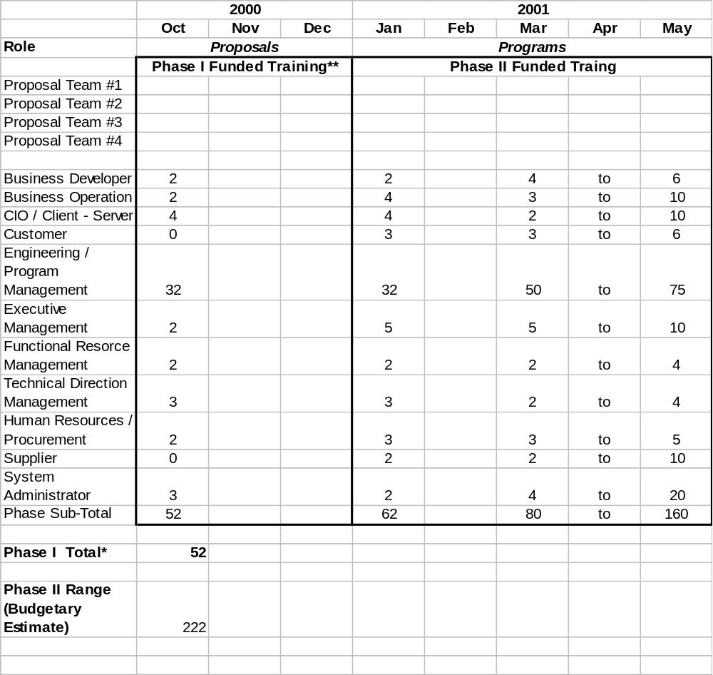* Table based on data supplied be George Wahlter.
**Second column of users must attend Phase I constructed courses while Phase 2 classes undergo development
Table 1. Number of LM EIS Windchill / MITIC Phase I users

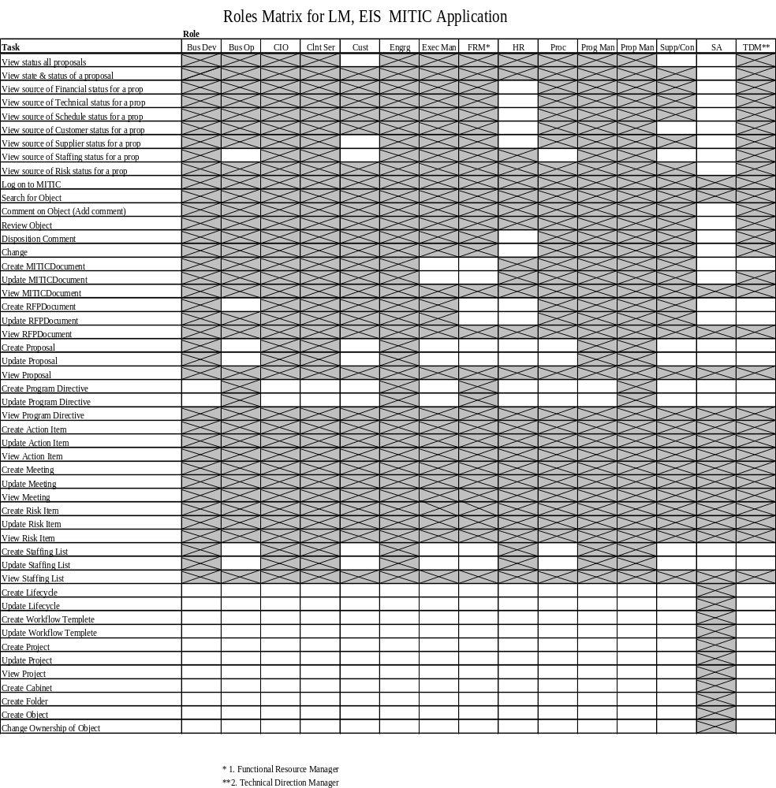
Table 2. LM EIS Role-Based Task Matrix

Appendix B – Prerequisite Information: Suggested Developer Schedule and Course Descriptions

Suggested Schedule

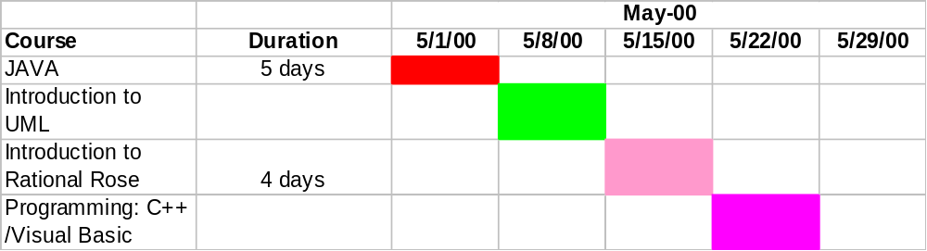
Table 1. Suggested Prerequisite Course Attendance

Windchill Prerequisite Course Descriptions

Course: Introduction to Java
Course Capacity:
For cost and scheduling Information:

Account Contact:
Gardner Kroeter
Phone: 800-422-8020 ext. 78500
Fax: 303-464-6862
email: gardner.kroeter@central.sun.com

Training Type: Sun Microsystems Instructor Led Training
Duration: 5 days

Course Name: SL275

Programmers familiar with object-oriented concepts will learn how to develop Java[tm] applications and applets. This course is used to teach students the syntax of the Java programming language; object-oriented programming with the Java programming language; creating graphical user interfaces (GUI), exceptions, file input/output (I/O), threads and networking.

Course Logistics:
Training at Customer Facility
OnSite courses are taught by Sun experts, using your equipment. This not only saves you time and travel costs, but also adapts the training to your specific environment. Courses can be run On-Site for up to 16 students maximum. Pricing is based on 12 student minimums.
Dedicated Classroom at a Sun Facility
Sun Educational Services can provide dedicated training for your organization. You may arrange to bring a group of students to a Sun training facility for training in a classroom environment dedicated to your company.
Sun Classroom Training
All our course materials are developed by industry experts who have access to the most current information on SunTM and UNIX® technology. Courses are ideal for groups and individuals throughout the organization and Sun teaches over 90,000 students in 150+ locations around the world.
Pricing: GSA Pricing is from GSA Contract GS-35F-4547G MA#33264.
On-Site:
SL-275 Java Programming Language 5-Day 12 student minimum $12,312
Additional Students $721 each to 16
Dedicated:
SL-275 Java Programming Language 5-Day 12 student minimum $15,514 Additional Students $1293 each to 16
Individual Training:
SL-275 Java Programming Language 5-Day $1,616 per student

Course: Object Oriented Project Management (OOPM) & Rational Unified Process

Course Capacity: A maximum of 12 students.
For cost and scheduling Information:

Contact: Texas Area Account Representative
Bret Kramer (972) 569-8745
Rational Phone Number: 1-800-728-1212

Training Type: Instructor Led Training by Rational University Education and Training
Duration: 4 days
Pre-Requisites: A basic knowledge about object technology is required
Objectives:
Upon completion of the course, the student will be able to:
- Manage complex projects effectively using object technology
- Determine when to use an iterative lifecycle rather than a waterfall approach
- Plan and manage an iterative development effort
- Determine desired levels of software reuse
- Select appropriate metrics for their first OO project

Object Oriented Project Management (OOPM)

Duration: 2 days
Overview:
This two-day course presents the best practices for successfully managing projects using object technology. These best practices include an iterative development approach, a risk-driven process, early focus on software architecture, and the measurement of progress and quality throughout the project.
Audience
Executives, technical managers, project leads, application experts, business analysts and software engineers involved with object technology will benefit from this course.
Agenda:
- Fundamentals of managing OO projects
- Five habits of successful OO projects
- Practices common to successful OO projects
- Risk management for OO projects
- The iterative lifecycle and its benefits
- Phases and milestones of the macro process
- Architecture-focused development
- Impact of reuse on the development process
- Project metrics
- Development teams
- The components of an effective tool environment
- Documentation: what is required and when
- Process assessment frameworks
- Survival techniques for the first OO project

Rational Objectory Process TM
Duration: 2 days
Overview:
The Rational Unified Process is a software engineering process that spans the entire project life cycle and guides the development team in conducting both management and engineering activities. This overview explains key concepts, including use case requirements capture, controlled iterative development, and early validation of software architecture. The course makes use of the Rational Unified Process 5.1 product toillustrate process organization, ease of navigation, and the details of process definition.
Topics Covered
- Understand the best practices for modern software engineering and the benefits they provide
- Understand the full software development life cycle within the context of these best practices
- Understand the phases and components of the Rational Unified Process
- Employ an iterative approach to planning a software development project and understand how it affects workers, activities, and artifacts
Prerequisites:
There are no prerequisites. No prior knowledge of these technologies is assumed.
Audience:
Process engineers, technical managers, project leads, analysts, designers, software engineers, configuration management personnel, testing and quality assurance personnel, and anyone needing an overview of the Rational Unified Process.
Objectives:
Upon completion of this course, participants will be able to:
- Describe the Rational Objectory Process in terms of its phases and components
- Explain the goals of each process component
- Explain the benefits of a process that is:
- Use-case driven
- Controlled and iterative
- Architecture-centric
- Configurable
- Describe the risk-driven approach to project management
- Explain why there is a need to configure the process for a specific organization or project
- Explain the importance of supporting the process with automated tools
Agenda:
- Objectory overview
- Controlled iterative development
- Business process modeling
- Requirements capture
- Software architecture
- Analysis and design
- Implementation
- Testing
- Project management
- Process configuration
- Tools to support automation of the process
Documentation:
A comprehensive course workbook including copies of all slides and exercises.

Course: Info*Engine CBT( Programming: C++ / Visual Basic)

The following computer based training (CBT) assignments below must be completed prior to attending the Info*Engine courses.

Agenda:
Day 1: Web Authoring Technologies

- CBT Designing Interactive Web Applications
- CBT Creating HTML Documents
- WBT Visit HTML web page references (Below)

Day 2: Database Technologies
- CBT Advanced Web Authoring: Javascript
- CBT Relational Principles

Day 3: Relational Principles
- CBT Relational Principles

Day 4: Programming Database Queries
- CBT SQL Programming: Database Queries
- C Programming 8 CBT C Programming: Introducing C

Day 5: C Programming

- CBT C Programming: Flow Control
- CBT C Programming: Text Processing

Advanced Assignments
- Internet, Intranet, and Extranet Technologies
- JavaScript Tutorial
- Advanced Web Authoring: CGI and PERL
- Internet Security: An Overview
- SQL Programming: Data Handling Techniques
- Interactive SQL Tutorial
- Java Database Connectivity
- Object-Relational DBMSs: Characteristics
- Oracle8 New Features: Object Technology and Other New Features

References
- HTML References:
- http://www.blooberry.com/
- http://www.authors.com/Navigator4/index.html
- Introduction to C Programming
- Virtual courses on the Web's C Info

Computer Based Training: Smart Force (CBT) Course Curriculum
Contact Information:
Anita Miranda
Corporate Consultant Sales
480-609-2606
anita_miranda@smartforce

All Windchill Professionals
All Windchill Professionals should complete the following courses in sequence
Course Sequence | Course Title | Comments
1 | Java -An Overview of Java
1 | Java – Introduction to the Java Language
1 | Java – Object Oriented Principles and Java
1 | Object Oriented Analysis - Objects & Classes
1 | Internet, Intranet & Extranet Technologies
1 | Enterprise Operating System Technologies
1 | Essentials of Windows NT
1 | Architecture of Windows NT
1 | Oracle 8: New Features: Object Technology and Other New Features
1 | UNIX: Overview
1 | UNIX: Exploring the File System
1 | UNIX: Working with Files

Solutions Architects and Developers:
Solutions Architects and Developers should also complete the following courses, in sequence:
Course Sequence | Course Title | Comments
2 | Object Oriented Design
2 | Principles of OOP I
2 | Principles of OOP II
2 | Database Technologies: Object Relational DBMSs: Characteristics
2 | Relational Principles | Part of I*E
2 | Internet and Intranet Skills - Setting Up a Website
2 | Internet and Intranet Skills - Website Administration
2 | Internet and Intranet Skills – Website Security
2 | Internet Security – Internet Security an Overview
2 | E-commerce: An Introduction
2 | Web A & P: Creating HTML Documents | Part of I*E
2 | WAN Technologies
2 | WinNT 4.0: Basic Configuration
2 | WinNT 4.0: Sharing and Securing Network Resources

Developers:
Developers should also complete the following courses in sequence:
Course Sequence | Course Title | Comments
3 | Internet and Intranet Skills - Designing Interactive Web Apps | Part of I*E
3 | Internet Security – Secure Communications
3 | Internet Security – Internet Site Security
3 | Internet Security – Firewall Principles
3 | Advanced Web Authoring: CGI and PERL
3 | Advanced Web Authoring: Javascript | Part of I*E
3 | WinNT 4.0: Managing Users and Groups
3 | WinNT 4.0: Network Configurations
3 | WinNT 4.0: Troubleshooting and Optimization
3 | WinNT 4.0:Advanced Networking, Printing and Integration
3 | WinNT 4.0: Advanced Troubleshooting and Optimization
3 | MS TCP/IP on Win NT 4.0: Connectivity in Heterogeneous Environments
3 | Database Technologies: Data Warehousing: The Fundamentals
3 | Database Technologies: Object Relational DBMSs: Mechanism and Implementation

Appendix C – Standard Windchill Course Descriptions

Course: Install the Windchill System Components

Course Code - TRN-851
Course Length - 2 Days

Overview

This course will cover the recommended installation process, as well as the procedures for configuring and troubleshooting, each Windchill Foundation and third party component. Through extensive demonstrations and hands-on lab exercises, students will gain experience in setting up an entire Windchill Foundation software installation. This will include practical experience with the required third party components, including Oracle8, a supported Web server, and the Java runtime files.

The course also includes a section on advanced installation options. These options can help to debug installation or configuration problems.

Upon completion of this course students will be able to install the entire Windchill Foundation, a standard environment, as well as a developer’s environment. Finally, students should also know how to load a demonstration database that can be used for pilot projects and customization environments.

Students who will benefit from this class include System Administrators, developers, implementation team members, and powerusers.

Prerequisites

- TRN-832 Introduction to Windchill
- Experience with Microsoft Windows NT Workstation or Server
- Experience with Windows NT Explorer and the MS-DOS command prompt

Topics
Students will learn how to install, configure, and test the following software:
- Windchill Foundation and PDM, including demonstration database
- Oracle8 Enterprise Server and Database
- Netscape Enterprise Server or Microsoft Internet Information Server
- JRun Servlet Engine
- Rational Rose 98
- Symantec VisualCafé
- Verity SEARCH’97
Advanced installation techniques that can improve the installation process

Course: Administer the Windchill Business Environment

Course Code - TRN-850
Course Length - 2 Days

Overview

This course teaches students the basic tasks a Business Administrator performs to support the Windchill business environment. Students learn to plan and create user accounts, and control what they can access within Windchill. Students also learn to plan indexing rules that enable them to share information across the enterprise. In addition, students learn to support their company’s business process by planning, implementing, and managing Windchill life cycles and workflow templates.

Upon completion of this course, students will understand the role of a Windchill Business Administer, and understand how the Business Administrator works with the System Administrator to support Windchill users. The student will gain the skills necessary to accomplish many typical daily tasks associated with the Business Administrator role. Students will be able to provide assistance to other Windchill users.

Students who will benefit from this class include Business Administrators, System Administrators, department heads, implementation team members, and powerusers.

Prerequisites

- TRN-832 Introduction to Windchill
- Knowledge of student company's own document management business rules and requirements

Topics

- Planning and creating user accounts and groups
- Planning and creating folders and cabinets
- Planning and configuring document access control
- Planning and configuring enterprise wide search criteria
- Notifying users of designated system events
- Managing business processes with life cycles and workflows
- Controlling product development processes with change management
Responding to common Windchill user requests and troubleshooting common Windchill user problems

Course: OOAD for Windchill
GSO University's Introductory OOAD (Object-Oriented Analysis and Design) for Windchill course is a five-day course offering. This is a beginner course designed to help you document the deliverables in an Object-Oriented project. It covers the UML notation, emphasizing the diagrams that will be most useful to a Windchill developer. Basic skills using Rose to store and organize both static and dynamic models will be covered. At the end of this course, you will be able to understand most Class Diagrams and apply the principles of Use Case Requirement Analysis. You'll also gain familiarity with best practices and heuristics used by OOAD experts.
This is a tool-centric course -- once Class Diagrams have been created, they are not only useful for documentation but they are also used for the purpose of code generation. Both the generic code generating capabilities of Rose and an introduction to the code generation capabilities of Info-Modeler will be examined.
The course begins with a review of Object-Oriented Programming history. It then proceeds to give an overview of object-oriented techniques and practices and demonstrates how UML is used to standardize the manner in which we communicate about our models.
By participating in individual labs as well as workshops, students will be required to demonstrate and improve their skills in creating models. Active participation in the classroom will be encouraged. Working towards the same goal as the rest of your team will be examined.

Training Medium: Instructor Led Training (ILT)
Class Duration: 5 days
Prerequisites: Attend the PIM Acceleration Module.
Objectives: This course is designed primarily for students enrolled in the Windchill Customization Module. the Windchill Customization Module one in a series of training modules contained in the PIM Professional Development Program. Attendees will receive a book titled "UML Toolkit".

Course: Create and Customize Windchill Applications

Course Code - 852
Course Length - 4 Days

Overview

In this class students will learn to create and customize Windchill programs. They will learn to support their company’s business requirements by applying their Object Oriented Analysis and Design (OOAD) programming skills and the Windchill Information Modeler to customize Windchill.

Students will learn to model, generate, and implement customized Windchill programs using the Windchill Integrated Development Environment (IDE). They will learn to model business objects and applications using Rational Rose. They will learn to create business artifacts, including client and server Java source code, Oracle database schema, and Windchill registry files. They will learn to use the Windchill System Generator to automate tasks by taking advantage of Windchill services. They will also learn to add custom services by extending the standard service model.

In addition to these skills, students will learn to customize the HTML and Java user interfaces. They will also learn to customize the user interface by using HTML templates, Windchill Java Beans, and other utilities.

Upon completion of this course, students will be able to customize and extend Windchill's product information management capabilities to match their company’s business objectives.

Prerequisites

- TRN-832 Introduction to Windchill.
- Java programming experience including: graphical programming (with AWT or Swing), events, exception handling, abstract classes, and interfaces.
- OOAD including familiarity with Unified Modeling Language (UML) class diagrams.
- Object Oriented Programming (OOP) including: application of OOP concepts such as encapsulation, generalization, aggregation, and associations.

Topics Covered

- Applying Web technology to customize Windchill
- Introduction to Windchill architecture
- Applying Rapid Application Development (RAD) concepts
- Updating the Windchill Database
- Modeling Business Objects with Rational Rose
- Creating custom server logic
- Customizing applications with standard Windchill server logic
- Developing Java client user interfaces
- Developing HTML user interfaces
- Improving inter-service communication with events
- Adding enumerated attributes to the Windchill system
- Loading external data into the Windchill database

Windchill Info*Engine Module
This module consists of three parts: Enabling Data Access, Configure for Data Acquisition, and Enable Screen-Based Data Acquisition. Each of this parts are detailed below:
The training begins with the rationale for using Info*Engine, an approach for analysis and design and the Info*Engine architecture. The functionality of Info*Engine is then introduced with extended segments on Webjects. This is followed by the EA adapter, which enables legacy systems to be included in a solution by capturing and recording screens. Finally, installation, administration and best practices are considered for both Info*Engine and the EA adapter.
This course is focused on developing skills through a series of hands-on exercises that iteratively introduce new topics while reinforcing those already presented. At the end of this course, students will understand how to analyze and design an Info*Engine solution. They will also gain the ability to work with the core Webjects and the EA screen-capturing technology.
Training Medium: Technology Based Training (TBT) and Instructor Led Training
Location: Per Training Schedule
Duration: 5 days
Prerequisites: Attend the PIM Acceleration Module.
Objectives:
- Awareness of the business case for Info*Engine
- Understanding of the Info*Engine architecture
- Understand analysis and design considerations in an Info*Engine solution
- Develop essential skills and understanding for working with Webjects

Configure for Data Acquisition Course Overview
The Configure for Data Acquisition training class will provide the ability to include information from remote systems on web pages via Webjects.
Duration: 2 days
The course addresses these areas of interest:
- Solving the Need to Automate Business Processes
- Querying & Displaying Data from Databases
- Modifying Data from Databases
- Authenticating Webjects
- Tuning Webjects
- Enhancing Web Pages
Agenda:
Solving the Need to Automate Business Processes
In this section students will learn what Info*Engine is, including:
- Business Scenarios/Processes that point to Windchill Info*Engine as a solution
- How to access data from a data repository using a web browser
- Process for creating automated business processes
- How Info*Engine does it
- The Info*Engine architecture
Querying & Displaying Data from Databases
In this section, students will learn how to query and display information from databases in order to solve a business problem, including:
- Scenarios where it is important to query and display data from a database
- How Webjects work
- Webject construction
Modifying Data from Databases
In this section, students will learn how to use Webjects to modify data, including:
- Business scenarios where it is important to create, update, and delete data from
- Action processing
- Uses of Action Webjects
Authenticating Webjects
In this section, students will learn how to set configuration parameters in order to control authentication, including:
- Setting configuration parameters
- Setting parameters for Oracle tables
Tuning Webjects
In this section, students will learn how to set configuration parameters in order to control:
- Login mapping
- Load-leveling
Enhancing Web Pages
In this section, students will learn business scenarios where it is important to enhance web pages, ensuring data integrity. This will include:
Scenarios where JavaScript can enhance Webjects
Audience:
This course has been designed to address the needs of:
Solution Architects: People who implement Info*Engine solutions as extensions of Windchill features or in stand alone environments using Info*Engine’s Webject technology in conjunction with other web technologies. Solution architects gain a detailed understanding of the core Info*Engine functionality. This information can be helpful extension to Windchill.
Prerequisites:
- HTML or XML file development experience
- Client-side JavaScript familiarity OR C, or C++
- UNIX experience
- FAMILIARITY LM Aero’s data model

Web Server administration Enable Screen-Based Data Acquisition
The Enable Screen-Based Data Acquisition training class will provide the ability to include information from screen-based remote systems on web pages via Webjects
Duration: 2 days
The course addresses four areas of interest:
- Web-enabling Screen-based Terminal Screens
- Installing the Server and EBAI Adapter
- Configuring the EBAI Adapter
- Enabling Data Access
Agenda:
Web-enabling Screen-based Terminal Screens
In this section students will learn what EBAI is, including:
- Business requirements for EBAI solution
- EBAI architecture
- Overview of Install and Configuration Process
Installing the Server and EBAI Adapter
In this section, students will learn how to install the Info* Engine server and the EBAI adapter.
- Info* Engine server installation
- EBAI adapter installation
- Testing
Configuring the EBAI Adapter
- In this section, students will learn the methodology for including information from screen-based systems on their web pages with Webjects. This will involve capturing screens, defining parameters for screens, generating methods for the desired screen behavior and finally
mapping methods to Webjects. Each of the topics below will be presented and demonstrated and followed by exercises, which build on each other toward a solution.
- Using terminal emulation
- Starting EA
- Capturing and saving screens
- Recording methods
- Configuring services
- Mapping methods to webjects
- Other EA concepts
- Using system monitor
- Best practices
- Trouble shooting
Enabling Data Access
In this section, students will learn how to use Webjects that access a screen-based system in a business solution.
- Map Webjects to methods
- Use Webjects in a solution template
Audience:
This course has been designed to address the needs of:
Solution Architects: People who implement Info*Engine solutions as extensions of Windchill features or in stand alone environments where screen-based data acquisition is required using the EBAI adapter. Solution architects gain a detailed understanding of the EBAI adapter functionality. This information can be a helpful extension to Windchill.
Prerequisites:
- MAINFRAME TERMINAL ACCESS FAMILIARITY
- C PROGRAMMING
- UNIX EXPERIENCE
- FAMILIARITY WITH 3270 EMULATORS
- INTRODUCTION TO WINDCHILL
- Configure for Data Acquisition

Analyze and Design a Data Acquisition System
The Analyze and Design a Data Acquisition System training class will provide the business analyst and solution architect with the ability to analyze business problems to solve the need to automate business processes pointing to Info*Engine and to design web solutions.
Duration: 1 day
The course addresses two areas of interest:
- Business Case Overview
- Developing Requirements based on Web Browsers
The following section summarizes the instructional content that is described in the outline.
Agenda:
Business Case Overview
In this section students will learn about business scenarios and processes that could use Info*Engine as a solution: Info*Engine and its architecture will also be introduced.
Developing Requirements based on Web Browsers
In this section, students will learn how to analyze business requirements and design a solution considering:
- System functions
- User actions
- Screen
- Navigation
- Data Requirements
Audience:
This course has been designed to address the needs of:
Business Analysts: People who analyze business needs and requirements in order to design a solution. Solution Architects: People who implement Info*Engine solutions as extensions of Windchill features or in stand alone environments.

VII. Appendix D – MITIC End User Custom Course Pricing

The following table depicts the cost associated with creating and instructor led custom MITIC end user training course.

Education Services
 | Education Product | Project | Unit Price | Quantity | Sub Total
 | Developer Assessment | 2.0 | $ 1850 / day | 5 days | $ 9,250
 | Materials Development | 9.0 | $ 1850 / day | 45 days | $ 83,250
 | Edit and Print | 9.0 | $ 1850 / day | 3 days | $ 5,550
 | Course Delivery | 9.0 | $ 10,800 / week | 5 deliveries | $ 54,800
 | Student Training Materials | 9.0 | No Charge | - | -
 | Materials Revisions | 10.0 | Quoted Separately | A/R | A/R
 |  |  |  | Total* | $ 152,850
* cost does not include Travel and Lodging for PTC instructor. Maximum allowance - $2500 per course delivery

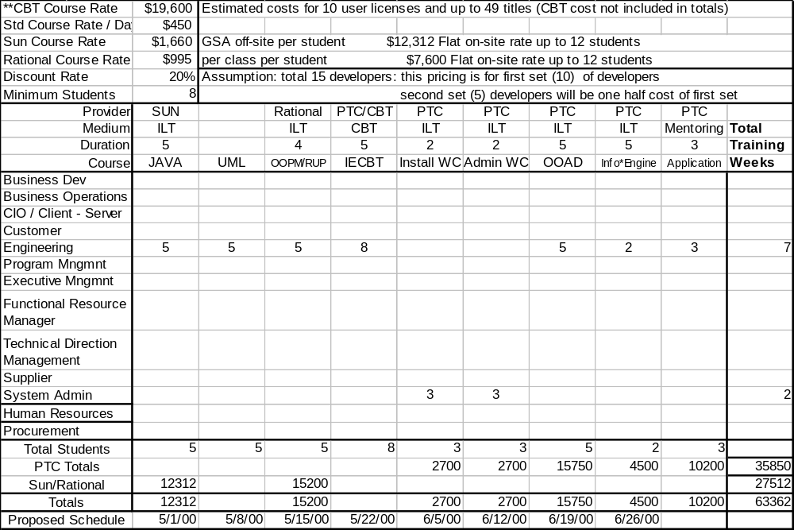

APPENDIX E: LM EIS Developer Training Pricing
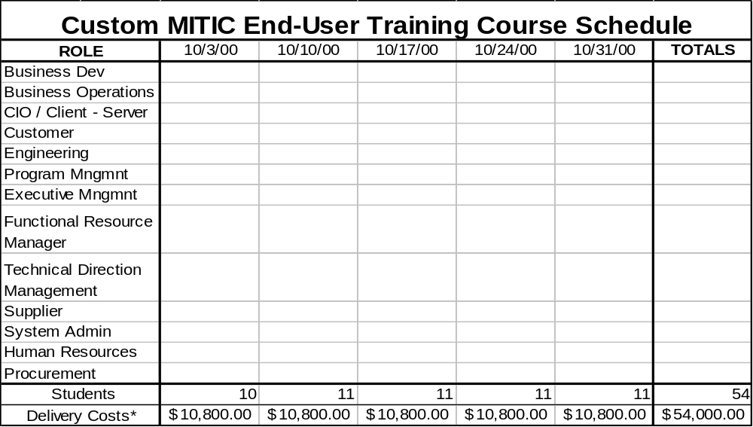

IX. APPENDIX F: Proposed Custom MITIC End-User Training Course Schedule

*Delivery costs include: Instructor, instructor teaching materials and training manuals
Delivery costs do not include: instructor Travel and Lodging expenses. Maximum allowance: $2500 per course delivery.
For optimum cost efficiency PTC Ed Services recommends no less than eight students per class and no more than twelve.

Appendix G – LM EIS Train the Trainer Pricing (Budgetary Estimate)

Education Services
 | Education Product | Project | Unit Price | Quantity | Sub Total
 | Standard Train the Trainer with Instructor Qualification | Phase II  9.0 | $28,500 min | 1 | $ 28,500
 | Standard Train the Trainer with Instructor Certification* | Phase II  9.0 | $55,080 min | 1 | $ 55,080
 | Train the Trainer “Qualification” Mentoring Delivery T&L | Phase II  9.0 | $500 / day | 9 days | $ 4,500
 | Train the Trainer “Certification” Mentoring Delivery T&L | Phase II  9.0 | $500 / day | 18 days | $ 9,000
 | Student Training Materials | Phase II  9.0 | $40 / guide | A/R | A/R
 | Train the Trainer Update Fee | Phase II  9.0 | $ 550 / year | A/R | A/R
 | Materials Revisions | Phase II  9.0 | Quoted Separately | A/R | A/R
 |  |  |  | Total* | $ 42,000 min
* Total value does not include Train the Trainer Instructor Certification program. Assumption: LM EIS will go with the “Qualification” or the “Certification” program but not both.

Appendix H – Pricing Summary

Phase I and Phase II Pricing Summary
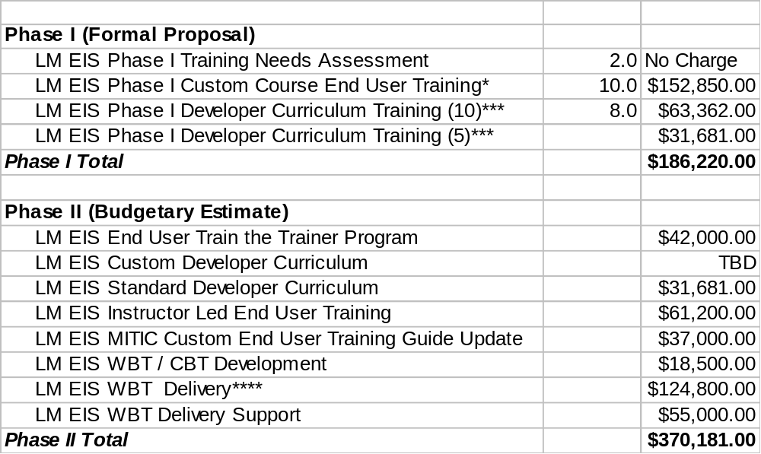
* cost does not include Travel and Lodging for PTC instructor. Maximum allowance - $2500 per course delivery
**cost is a MINIMUM value; further discussions regarding custom developer curriculum, delivery of WBT’s and the LM EIS resale of WBT’s could significantly increase this value.
Also, Train the Trainer cost not included in Phase II sub-total.
***Cost is for a total of 15 developers. Assumption: second set (5) one half price of original set (10).
****”Early Adopter Price”, Cost is a minimum based on 240 users.

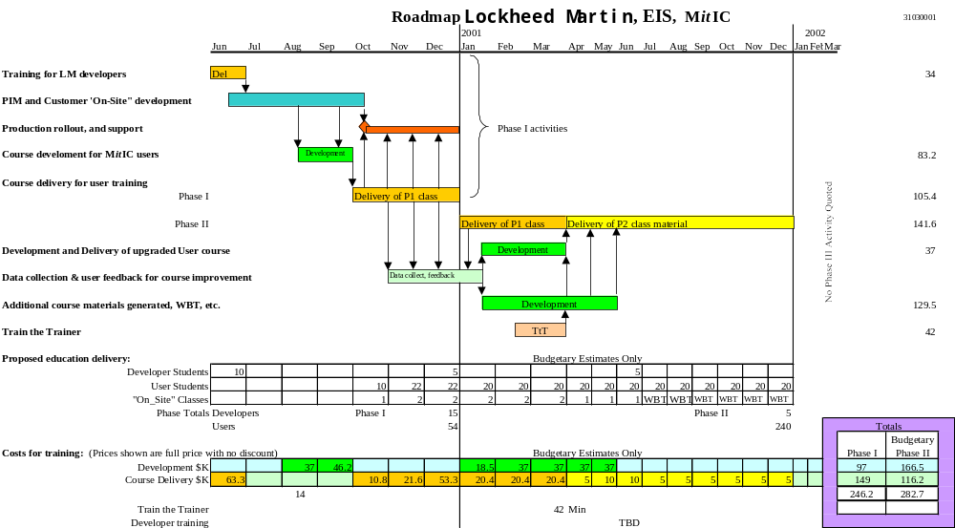

APPENDIX – I: Windchill / MITIC Training “Road Map”

APPENDIX J - General Notes

- Parametric Technology Corporation reserves all rights to the materials developed under this project. No portion of the developed materials may be reproduced or utilized in any form, or by any electronic, mechanical, or other means, without the prior written permission of Parametric Technology Corporation. All training materials will be developed using Release 5 of Windchill and associated software products. Revision updates to the developed materials are available for an additional development fee.

- The development efforts described are estimates. These estimates are based on past development experience, and our understanding of the Customer requirements. PTC uses these estimates to determine manpower and scheduling requirements to meet the agreed upon delivery dates. Supporting materials from the Customer will be requested in advance, and need to be made available within the specified timeframes to maintain the development schedule. In the event of a pending schedule slip, PTC will immediately contact the Customer for the purpose of creating a recovery plan.

- PTC makes every effort to ensure that the training course materials are error free, but cannot guarantee the absence of all errors that may be found during delivery at the Customer location. After final edit, the materials are transferred to the Publisher for replication and binding, the scheduling of which is based on the Publisher’s workload.

- Terms for the Train the Trainer program will be determined once LM EIS MITIC program management has decided to execute the option to proceed with the PTC Education Services Train the Trainer program

- Training rooms for course delivery must be setup by the Customer and meet the following minimum requirements:
- A room capable of accommodating 12 students, the training hardware, and the instructor
- A minimum of 1 workstation for each pair of students, configured to meet the hardware configuration requirements as defined in the PTC Hardware Configuration Notes
- Fully licensed PTC software, complete with all modules appropriate to the course being taught
- A transparency projector
- A dry-erase board or chalk board and appropriate writing tools
- A method of providing live software demonstrations is strongly suggested

- Travel and lodging expenses for PTC Education Specialists during the course development and/or course delivery are the responsibility of the Customer. These expenses are based on actual travel and lodging expenses as documented through the PTC expense report process, and must be covered on the Customer purchase order. The maximum expense amount per on-site visit at the Customer is not to exceed $2,500. Each on-site visit is not to exceed one business week in duration. PTC standard business practice is to schedule resources and travel arrangements in a cost-effective manner within PTC travel policy guidelines. Whenever possible, PTC will work with the Customer to schedule on-site visits in a manner that reduces the overall travel and lodging expenses.

- By soliciting this proposal, the Customer understands and agrees that the information contained within is the proprietary and confidential information of PTC which may not be disclosed at any time during negotiations or thereafter, directly or indirectly, to any third party or parties. Furthermore, by soliciting this proposal, the Customer understands and agrees that the Customer may not use the information and materials developed as a result of this proposal other than in direct involvement with PTC.

